Power BI Excel Export – New PC Setup & Test Guide
Oct 13, 2026 · @Anshuman

Overview
About 30 minutes gets a new PC running the app at http://localhost:5500 and through a full test, provided the Azure and Power BI access already exists.
The app is a static web page: plain HTML, CSS and JavaScript, with no build step and no backend. It signs you in with Microsoft, shows a Power BI report inside the page, reads each visual's data with the Power BI JavaScript SDK, and builds a formatted Excel file in the browser with ExcelJS. Report data never leaves the browser.
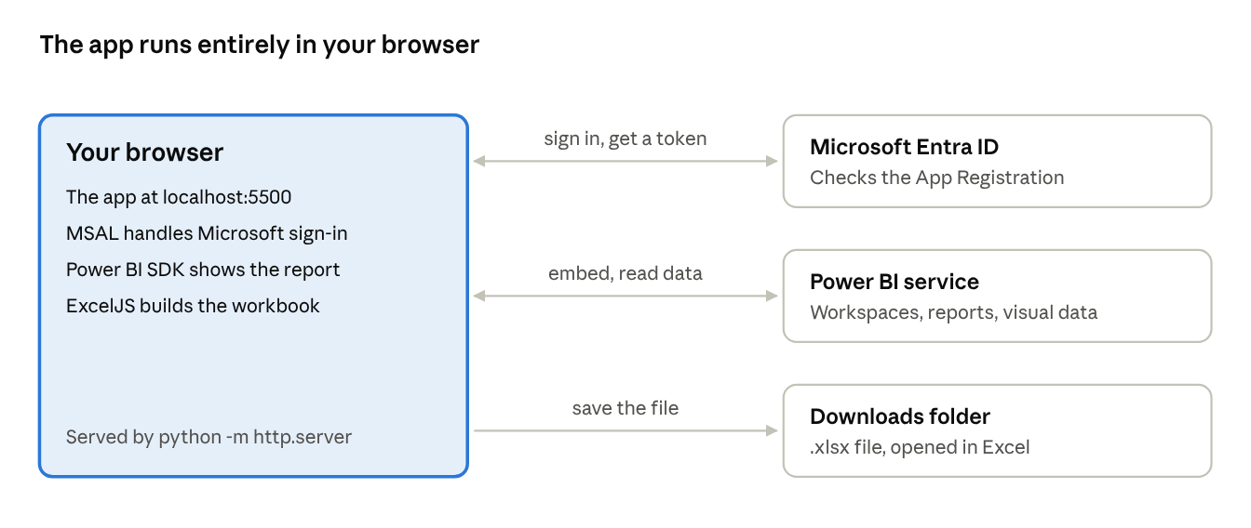
how the app works · browser, Entra ID, Power BI, Excel
The only server involved is the local web server that hands the six files to the browser; sign-in goes to Microsoft and data comes straight from Power BI.
This guide covers installing the tools, getting the code from GitHub, configuring it, running it locally, a first export, and a test checklist to sign off a build.

Prerequisites
You need three pieces of software, a NeenOpal work account with a Power BI licence, and an App Registration someone has already set up.
Software on the new PC
Tool | Why | How to check
Git | Clone the repo | git --version
Python 3 (any recent version) | Runs the local web server on port 5500 | python --version
Microsoft Edge or Google Chrome | Runs the app; downloads land in the normal Downloads folder | Open it
VS Code (optional) | Editing; Live Server can replace Python | Open it
Microsoft Excel | Opening the exported file | Open it
No Node.js, npm packages or build tools are needed. The app loads MSAL, the Power BI SDK and ExcelJS from the jsDelivr CDN and JSZip from cdnjs, so the PC needs internet access to cdn.jsdelivr.net and cdnjs.cloudflare.com.
Accounts and access
- A NeenOpal work account (personal Outlook or Hotmail accounts don't work with Power BI).
- A Power BI Pro licence or Pro trial on that account.
- At least one workspace with reports you can open, ideally reports that use DAX measures, slicers and more than one page.
Already set up in Azure (check, don't recreate)
- App Registration Export to Excel in NeenOpal's Entra ID. Client ID 8d911d46-08a2-4fd4-ae8a-651922cbdce3, tenant ID 38d5e40c-9bd6-41fb-8951-c387c97018d9.
- Power BI admin settings Embed content in apps and data export turned on for your account.

Step 1 – Get the code
Clone the repo into a folder of your choice. The app files sit at the repo root.
- Ask Jeyaseela Pandian for access to the GitHub repo Jeyaseela-pandian/Power-BI-excel-export if you don't have it.
- Open a terminal in the parent folder and run:
git clone https://github.com/Jeyaseela-pandian/Power-BI-excel-export.git
cd Power-BI-excel-export
- Check you have these seven files: index.html, styles.css, config.js, app.js, colors.js, export.js, ui.js.
- Later, to get the newest version: git pull origin main.

Step 2 – Configure
For local testing at NeenOpal, config.js needs no changes; just confirm the App Registration matches it.
config.js values
Setting | Value | Change it when
clientId | 8d911d46-08a2-4fd4-ae8a-651922cbdce3 | A different App Registration is used
tenantId | 38d5e40c-9bd6-41fb-8951-c387c97018d9 (NeenOpal) | Testing from another organization: use that organization's tenant ID, or organizations
redirectUri | http://localhost:5500 | Hosting at another address; it must match the App Registration exactly
productName | NeenOpal Export for Power BI | Rebranding
App Registration checklist (entra.microsoft.com → App registrations → Export to Excel; ask its owner if you can't open it)
- ☐ Authentication: platform Single-page application with redirect URI exactly http://localhost:5500. Not "Web", not 127.0.0.1, not https.
- ☐ API permissions: Power BI Service → Delegated → Report.Read.All, Workspace.Read.All and Dataset.Read.All. Dataset.Read.All lets the app read the report file for exact chart colours (including colours set by hand on a visual). It is asked for separately, so sign-in and export still work without it; the colours then follow the report theme.
- ☐ Status shows Granted for NeenOpal (green tick). If not, an admin clicks Grant admin consent.
- ☐ Certificates & secrets: nothing needed; the app uses no secret.
- ☐ Supported account types: My organization only is fine for NeenOpal testing; customers need Multitenant.

Step 3 – Run the app locally
Serve the repo folder on port 5500 and open it as localhost, never 127.0.0.1, or Microsoft sign-in rejects the address.
Option A – Python (recommended)
- In a terminal at the repo root:
python -m http.server 5500
- Open http://localhost:5500 in Edge or Chrome.
- Leave the terminal open while testing; press Ctrl+C to stop the server.
Option B – VS Code Live Server
- File → Open Folder → the repo folder. It must be the root folder in VS Code, not a parent.
- Install the Live Server extension, then right-click index.html → Open with Live Server.
- Live Server opens 127.0.0.1:5500: change the address to localhost:5500, or set "liveServer.settings.host": "localhost" in VS Code settings.
Check it worked: the page shows Export a full report page to Excel in one click and a Sign in with Microsoft button. If port 5500 is busy, stop whatever uses it; another port would also need adding to the App Registration.

Step 4 – First sign-in and export
A first export should take under a minute and produce an .xlsx file in your Downloads folder.
- Click Sign in with Microsoft and sign in with your NeenOpal account. The first time, accept the permissions prompt (or ask IT if it says admin approval is needed).
- You land on the app: the workspace list on the left, your initials top right. Pick a workspace, then click a report in the list (or paste an app.powerbi.com report link into Open from link).
- Wait for the report to load. The page name shows under the report name.
- Click Export to Excel. A progress window shows each page and visual; the file downloads and a message confirms the file name and counts.
- Open the file in Excel and check that no We found a problem with some content message appears.
For more control, click the ▾ next to Export to Excel: pages, visuals, layout, long-table collapsing and what to include. The gear icon top right holds branding (company name, logo, accent colour, table style, footer) and Diagnostics.

Step 5 – Test plan
A build is signed off when all 19 checks pass on at least two reports: one with DAX measures and slicers, one with three or more pages. Set each Result as you go.
# | Area | What to do | Expected result | Result
1 | Start-up | Open http://localhost:5500, press F12 → Console | Landing page shows; no red errors in the console | Not run
2 | Sign-in | Sign in with Microsoft | Back on the app with your initials top right and workspaces listed | Not run
3 | Report list | Switch workspace; type in the search box | List reloads; search narrows it to matching names | Not run
4 | Open from link | Paste a report link copied from app.powerbi.com, click Open | That report opens on the page in the link | Not run
5 | Current page export | Click Export to Excel | One sheet named after the page; title, export time and filter lines at the top | Not run
6 | Data accuracy | Compare 3 values with the report, including one DAX measure | Values match; SUM works on number columns; %, currency and dates look right | Not run
7 | Layout: like the report | Options → Layout: Like the report, export | Visuals sit left/right/above/below as on the page; tops line up | Not run
8 | Layout: stacked | Options → Layout: Stacked, export | One visual under another, all starting in column A | Not run
9 | Table filters | In Excel, use a table's filter and sort buttons | Each visual is its own Excel table; sort works per table | Not run
10 | Long tables | Export a table with 20+ rows; then set rows visible to 5; then turn collapsing off | First N rows visible, rest behind [+]; N follows the setting; nothing hidden when off | Not run
11 | Slicers | Set a date range and a list slicer, export | Lines read like Date: 6/7/2024 – 8/18/2024 and Field: value; untouched slicers show All | Not run
12 | Visual checklist | Options → untick one visual, export current page | That visual is missing from the file | Not run
13 | All visible pages | Options → All visible pages, export | One sheet per visible page; hidden pages skipped; report returns to the page you were on | Not run
14 | Choose pages | Options → Choose pages, tick two including a hidden one | Exactly those two sheets | Not run
15 | Branding | Gear → add company name, logo, accent colour, table style, footer; Save; export; reload the app | All five appear in the file; settings are still there after reload | Not run
16 | Cancel | Start an all-pages export, click Cancel | "Export cancelled"; no file downloaded; Export button works again | Not run
17 | Excel opens cleanly | Open each exported file in desktop Excel | No repair prompt; tables, formats and [+] buttons intact | Not run
18 | Diagnostics & sign-out | Gear → Diagnostics → Run checks; then Sign out | Every visual listed with OK / no data / FAILED; sign-out returns to the landing page | Not run
19 | Chart colours | Export the test report's Colour test page (test-samples/README.md). If Options → Colours shows Allow exact colours, click it first | Series headers and value cells in the exact report colours, including legend and category colours and colour rules; the bar coloured by hand matches; without the permission a note says the theme colours were used | Not run
For a failure, note the report, page and visual, and copy the Diagnostics table and Activity log (gear → Diagnostics) into the bug report.

Troubleshooting
Most setup failures are the address (localhost vs 127.0.0.1) or a missing permission on the App Registration.
Symptom | Cause | Fix
AADSTS50011 redirect URI mismatch | Opened 127.0.0.1, wrong port, or URI not registered | Use http://localhost:5500; check the SPA redirect URI
AADSTS700054 or response-type error | Redirect URI registered as Web | Re-add it under Single-page application
AADSTS65001 / "Need admin approval" | Consent not granted | An admin clicks Grant admin consent for NeenOpal
AADSTS700016 / AADSTS50020 | App not in your tenant, or tenantId points elsewhere | Use NeenOpal's tenant ID; another organization needs a multi-tenant app
Signed in but no workspaces or reports | No Power BI licence, or no workspace access | Start a Pro trial or get a licence; ask for access to a workspace
401 after sign-in | Expired session or no licence | Sign out and in again; check the licence
Report area stays blank | "Embed content in apps" is off | Fabric admin enables it in the Power BI admin portal
Visuals show Export failed | Export is off for the tenant or the report | Turn on data export in admin settings and in the report's own settings
Text box, shape or button shows no data | Expected: these hold no data | Nothing to fix
Excel offers to repair the file | Bug in the export | Send the file, the report name and the Diagnostics output to the developer
Page loads unstyled or blank | CDN blocked by a firewall or proxy | Allow cdn.jsdelivr.net and cdnjs.cloudflare.com
Branding resets after reload | Browser blocks site storage (private window) | Use a normal window
Note: chart colours follow the report theme; a bar coloured by hand comes out in a theme colour | Dataset.Read.All not granted, no Contributor (or higher) access to the workspace, or report downloads turned off | Options → Colours → Allow exact colours; an admin grants consent for Dataset.Read.All; get Contributor access; turn on Download reports in the Power BI admin portal
Allow exact colours shows Need admin approval | Users may not consent to new permissions in this tenant | An admin adds Dataset.Read.All to the App Registration and clicks Grant admin consent

Reference
Files
File | What it does
index.html | Page layout: landing page, report picker, export options drawer, branding, progress and diagnostics dialogs
styles.css | All styling
config.js | Client ID, tenant ID, redirect URI, product name
app.js | Microsoft sign-in (MSAL), Power BI REST calls, report list, report links, embedding, filter descriptions
colors.js | Reads the report file (both report formats) for the exact theme and colours set by hand on each visual
export.js | Reads each page's visuals, lays them out and writes the Excel workbook
ui.js | Options, branding settings, progress, toasts, diagnostics; starts the app
Useful addresses
- App: http://localhost:5500 (add ?debug=1 to open Diagnostics after sign-in)
- Open a report directly: http://localhost:5500/?groupId=<workspace id>&reportId=<report id>&pageName=<page name> (leave out groupId for My workspace)
- Repo: https://github.com/Jeyaseela-pandian/Power-BI-excel-export
- App Registration: entra.microsoft.com → App registrations → Export to Excel
- Power BI admin settings: app.powerbi.com → Settings → Admin portal → Tenant settings
Limits to know when testing
- Up to 30,000 rows per visual; charts come out as their data tables, not pictures.
- R/Python and some custom visuals can't be exported; text boxes and buttons have no data.
- Excel filters hide whole rows, so in the Like the report layout, filtering one table also hides rows of tables beside it. Use Stacked when filtering matters.

